ESP8266 Development Board

Rev. A0

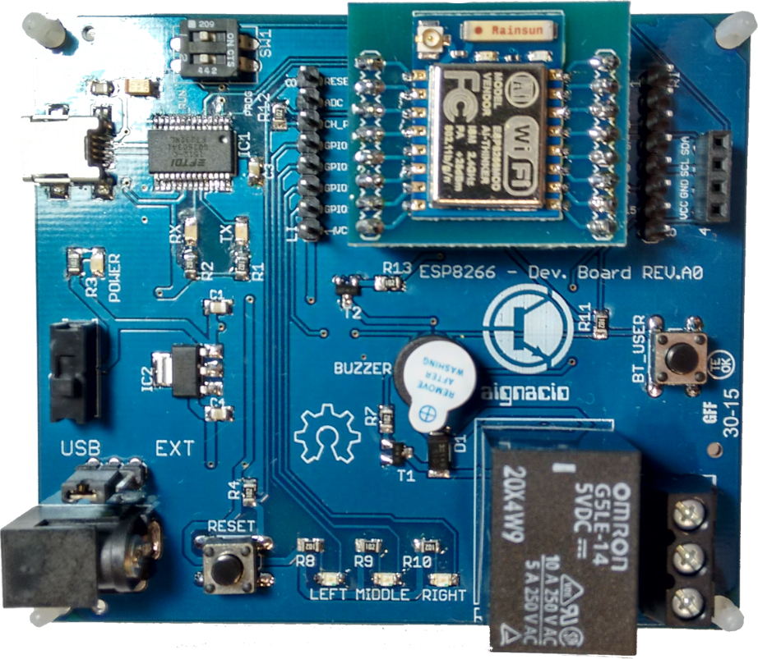

July 2015. aignacio

Table of Contents

Introduction 3

Schmactics 4

Features 5

Bom List 6

Software 8

# Introduction

Congratulations for acquires the ESP8266 development board!. This board can help you to develop new applications with the ESP8266 using IoT(Internet of Things) concept, this device has a lot of environments and methods to develop applications for example we have [***espduino(wifi library)***](https://github.com/tuanpmt/espduino) and [***nodemcu(lua based script)***](https://github.com/nodemcu/nodemcu-firmware)tools, that can be a huge option to start creating your idea and test it on this board. I’m developer like you and if you want to change some mails don’t be afraid, just send to [mailto:anderson@aignacio.com?subject=Contact about Dev. Board](mailto:anderson@aignacio.com?subject=Contact%20about%20Dev.%20Board) and soon as possible I answer you.

Hardware

The ***ESP8266 Dev. Board*** has been designed to be simple as the module and then you can see the schematics below to know a little bit more about what we have on this board. Basically you have a communication block, where’s a usb -> serial converter (*FR232RL)*, a power block where contains the main 3.3VDC regulator and a GPIO block that’s connected to the ESP8266 Module.

## Schmactics

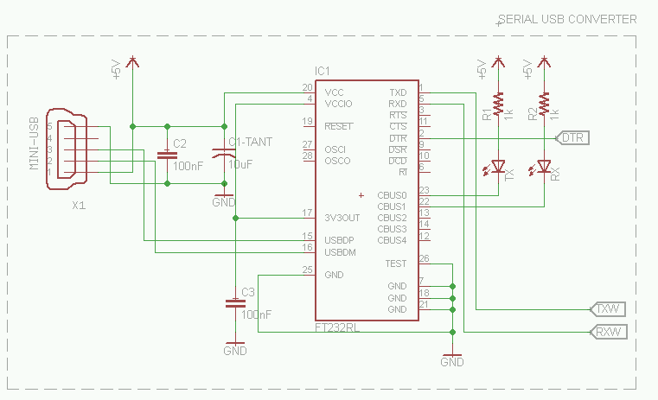

Figure 1 - Communication Block

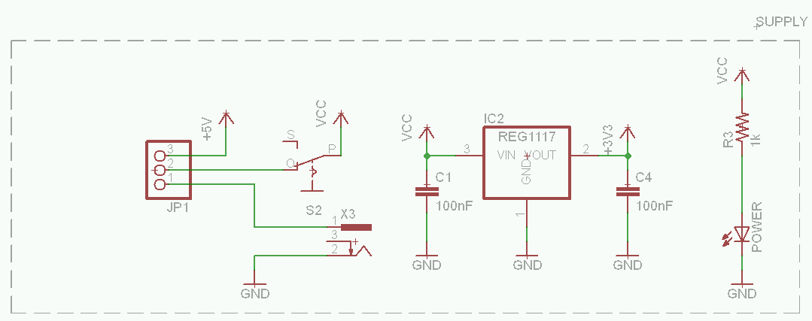

Figure 2 - Power Block

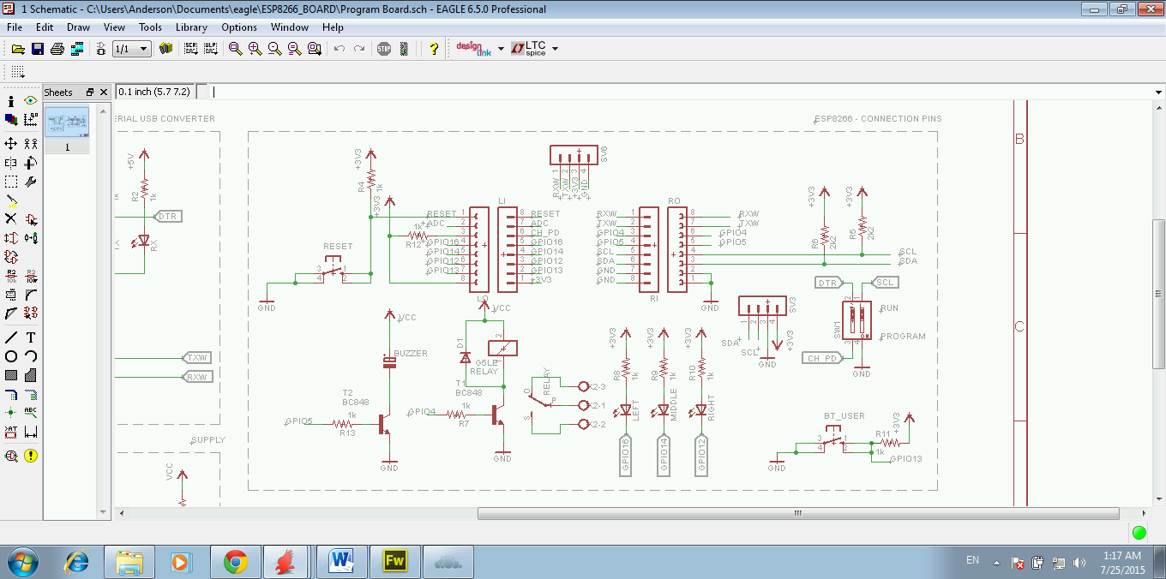

Figure 3 - GPIO Block

## Features

The board has some features that can be used in code:

* Buzzer
* Relay 250V/10A
* 3x LED
* Push-button for general purpose

These features are connected to the following GPIO pins on the ESP8266 module:

* Buzzer – **GPIO5** – Activate on **HIGH or “1” Logic –** Can also use a PWM output
* Relay 250V/10A – **GPIO4** - Active on **HIGH or “1” Logic** – Do not use PWM!
* 3x LED – **GPIO16/14/12** - Active on **LOW or “0” Logic**
* Push-button with a **pull-up resistor** - **GPIO13**

## Bom List

The components of the board are listed below, with digi-key part-number and images:

|  |  |  |  |
| --- | --- | --- | --- |
| **Components** | **Parts** | **Part-Number** | **Description** |
| Recorte de Tela   |  | | --- | |  | | 1 | 668-1219-ND | BUZZER MAGN 3VDC 2.7KHZ PCB |
| |  | | --- | |  | | 1 | H2961CT-ND | CONN RECEPT MINI USB2.0 5POS |
| |  | | --- | |  | | 1 | 399-3684-1-ND | CAP TANT 10UF 10V 10% 1206 |
| |  | | --- | |  | | 10 | 311-1.0KARCT-ND | RES SMD 1K OHM 5% 1/8W 0805 |
| |  | | --- | |  | | 2 | 311-2.2KARCT-ND | RES SMD 2.2K OHM 5% 1/8W 0805 |
| |  | | --- | |  | | 30 | 160-1645-1-ND | LED 468NM BLUE CLEAR 0805 SMD |
| |  | | --- | |  | | 3 | 160-1423-1-ND  LTST-C171GKT | LED GREEN CLEAR THIN 0805 SMD |
| |  | | --- | |  | | 2 | 568-4868-1-ND | TRANS NPN 30V 0.1A SOT23 |
| |  | | --- | |  | | 1 | EG1903-ND | SWITCH SLIDE SPDT 200MA 30V |
| |  | | --- | |  | | 1 | CT2092MS-ND | SWITCH RAISED ACTUATOR 2 SEC 50V |
| |  | | --- | |  | | 1 | 281-3179-ND | CONN TERM BLOCK PCB 5MM 3POS BK |
| |  | | --- | |  | | 2 | 3M9518-ND | CONN SOCKET SGL VERT 8POS GOLD |
| |  | | --- | |  | | 1 | 3M9515-ND | CONN SOCKET SGL VERT 4POS GOLD |
| |  | | --- | |  | | 1 | 768-1007-1-ND | IC USB FS SERIAL UART 28-SSOP |
| |  | | --- | |  | | 1 | 3M9580-ND | SHUNT JUMPER .1" BLACK GOLD |
| |  | | --- | |  | | 1 | Z1011-ND | RELAY GEN PURPOSE SPDT 10A 5V |
| |  | | --- | |  | | 1 | AZ1117CH-3.3TRG1DICT-ND | IC REG LDO 3.3V 0.8A SOT223 |
| |  | | --- | |  | | 1 | CP-057A-ND | CON PWR JCK 2.0 X 6.3MM |
| |  | | --- | |  | | 4 | 399-1170-1-ND | CAP CER 0.1UF 50V 10% X7R 0805 |
| |  | | --- | |  | | 1 | S1G-FDICT-ND | DIODE GEN PURP 400V 1A SMA |
| |  | | --- | |  | | 2 | 952-2271-ND | SIL VERTICAL PC TAIL PIN HEADER |

# Software

This board is open source and all files (pcb eagle sheets, gerber, firmware…) can be found on this link. To program a new module with default firmware, that can test all GPIOs of this board, download the repository on github and program the followings binaries on this address of esp8266:

* 0x00000.bin on 0x00000 address
* 0x40000.bin on 0x40000 address

When you program, you will see a demo code running on this board. To program the board, just push the switch to mode “**prog**” on the dev. Board, after change it to “**run**”. See image below:

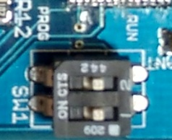

Figure 4 – Switch to program/run firmware